Lab Practical #02:
Study of different network devices in detail.
Practical Assignment #02:
- Give difference between below network devices.
- Hub and Switch
- Switch and Router
- Router and Gateway
- Working of below network devices:
  - Repeater
  - Modem((DSL and ADSL)
  - Hub
  - Bridge
  - Switch
  - Router
  - Gateway

Hub and Switch
No. | Hub | Switch
1 | Broadcasts data to all devices on the network. | Sends data only to the specific device it’s intended for.
2 | Less efficient; more data collisions due to broadcasting. | More efficient; reduces collisions with direct data transfer.
3 | Operates at Layer 1 (Physical Layer) of the OSI model. | Operates at Layer 2 (Data Link Layer), and sometimes Layer 3.
4 | Does not learn or store MAC addresses. | Learns and stores MAC addresses to intelligently forward data.
5 | Slower; typically supports lower speeds (10/100 Mbps). | Faster; supports higher speeds (up to 1 Gbps or more).

Switch and Router
No. | Switch | Router
1 | Connects multiple devices within a local network (LAN). | Connects different networks (e.g., LAN to the Internet).
2 | Operates at Layer 2 (Data Link), sometimes Layer 3. | Operates at Layer 3 (Network).
3 | Does not assign IP addresses; forwards based on MAC addresses. | Uses IP addresses to route packets between networks.
4 | Uses MAC address table to forward data. | Uses routing tables and protocols to determine the best path for data.
5 | Cannot provide direct Internet access to devices. | Provides Internet access by routing data from LAN to ISP and vice versa.

Router and Gateway
No. | Router | Gateway
1 | Connects multiple networks, usually similar types (e.g., LAN to WAN). | Connects two different systems or networks using different protocols.
2 | Routes data packets between networks using IP addresses. | Translates data between different network architectures or protocols.
3 | Works mainly at Layer 3 (Network). | Can operate at any OSI layer, especially Layer 5-7 if protocol conversion is needed.
4 | Does not perform protocol translation. | Performs protocol conversion (e.g., IPv4 to IPv6, TCP/IP to ATM).
5 | Used to connect LAN to Internet (via ISP). | Used as entry/exit point in networks to handle different protocols or systems.

Working of below network devices:
- Switch
A network switch is like a smart traffic controller inside a building (your network).
Step-by-step:
- Connects Devices
It connects devices like computers, printers, and Wi-Fi access points in a local area network (LAN).
- Learns Device Addresses
Each device has a unique ID called a MAC address.
The switch remembers which MAC address is connected to which port.
- Sends Data Smartly
When one device sends data, the switch looks at the destination MAC address and sends the data only to that specific device, not to all.
- Avoids Unnecessary Traffic
This saves time and bandwidth because only the intended device gets the data.
- Fast and Efficient
It works very fast, managing communication inside your network efficiently.
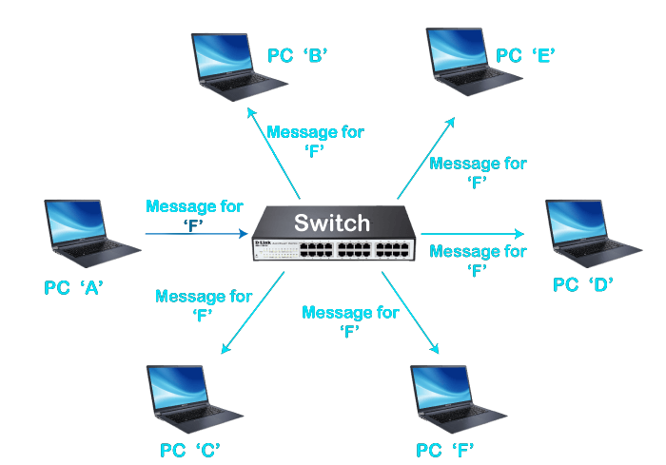

- Router
A router is like a post office that connects your home or office network to the internet and routes data between different networks.
Step-by-Step:
- Connects Networks
A router connects your local network (LAN) to the internet (WAN).
- Assigns IP Addresses
It gives each connected device (phone, laptop, TV) a unique local IP address, so they can be identified.
- Sends Data to the Right Place
When you open a website, your request goes to the router.
The router sends it to the internet, and when the website responds, the router brings the data back to your device.
- Routes Smartly
It looks at IP addresses to figure out the best path for the data to travel.
- Adds Security
Many routers include a firewall and NAT (Network Address Translation) to help protect your devices from external threats.
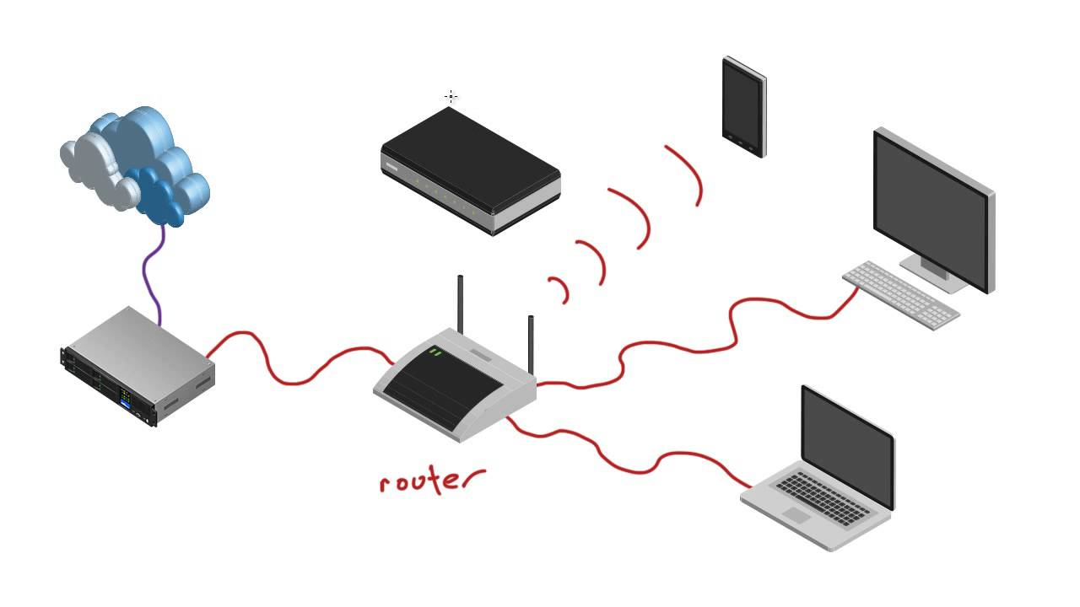

- Gateway
A gateway is like a translator or bridge between two different types of networks or systems.
Step-by-Step:
- Connects Dissimilar Networks
A gateway connects networks that use different communication protocols (rules for talking).
- Translates Data
It converts the data format from one network type to another, so they can understand each other.
- Acts as Entry/Exit Point
A gateway is the entry and exit point for your local network to communicate with other networks or the internet.
- Handles Complex Tasks
It may work at higher layers of the OSI model (like session, presentation, or application layer) to do protocol conversion, data translation, or even encryption/decryption.
- Used in Special Cases
It's commonly used when connecting IoT devices, enterprise systems, or different types of networks (like IP to Bluetooth, or email to SMS).
